Edge Detection

**Summarization**:

1/ Objectives: why we need to extract edges and methods for extrating edges

2/Problem: Something it not working as we expected base on the complexity of the image.

**Method of extraction:**

1/Sobel operator:

It work by calculating the gradient of image intensity at each pixel in the image. The result shows how abruptly or smoothly the image changes at each pixel, therefore knowing if the pixel represent an edge or not.

It use two 3x3 matrix. One for x – direction and one for y – direction.

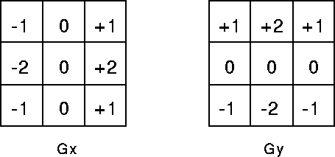

Each matrix is then convolved with each pixel in the image to produce the gradient matrix with the x and y direction respectively. After the we use Pythagorean equation to fine the gradient magnitude matrix. The major disadvantage of Sobel operator was the signal to noise ratio. With the increase in noise the gradient magnitude of the edges also degrades which produces inaccurate results.

2/ Laplacian of Gaussian

It is a method of finding edges using second derivative. Because the sobel operator use first derivative to find the peak of the intensity curve, it is sometime hard to define where exacly the position of the edges. But with the second derivative, you just have to look for when it cross zero to find the location of the edge. Because we're working with second order derivatives, the laplacian edge detector is extremely sensitive to noise so we may need to aplly a gaussian filter before doing it.

3/ Canny edge detection

The Canny edge detector is an edge detection operator that uses a multi-stage algorithm to detect a wide range of edges in images. The Process of Canny edge detection algorithm can be broken down to 5 different steps:

1. Apply Gaussian filter to smooth the image in order to remove the noise
2. Find the intensity gradients of the image
3. Apply non-maximum suppression to get rid of spurious response to edge detection
4. Apply double threshold to determine potential edges
5. Track edge by hysteresis: Finalize the detection of edges by suppressing all the other edges that are weak and not connected to strong edges.

**Examples:**

In folder.

**Conclusion:**

Edge detector is a basic method that require in many advance job from image processing to object recognition as well as image matching. That why we need to understand how it work.